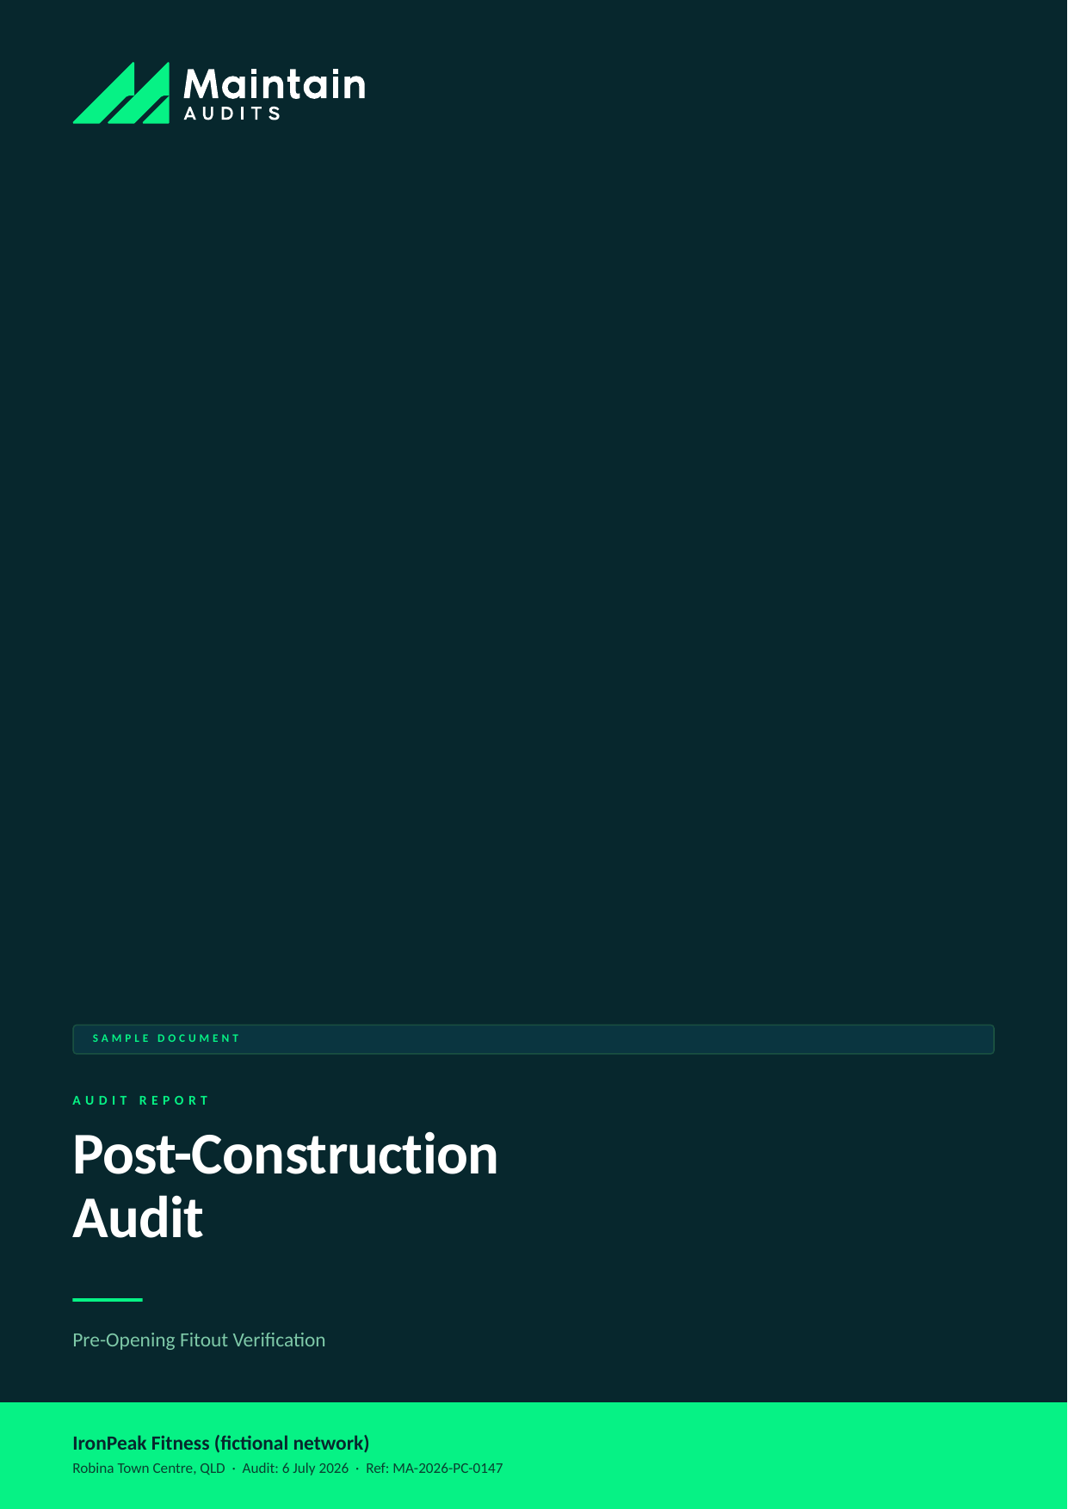

Client (fictional) | IronPeak Fitness (fictional network)
Location | Robina Town Centre, QLD — new club, pre-opening
Audit type | Post-Construction Audit
Audit conducted | 6 July 2026
Report issued | 8 July 2026 (48-hour turnaround)
Lead auditor | M. Harker, Senior Auditor — Maintain Audits
Report reference | MA-2026-PC-0147
Distribution | Franchisor head office; franchisee principal — Commercial in confidence

SAMPLE DOCUMENT — all client details and findings are fictional, prepared to demonstrate Maintain Audits' reporting format.

SECTION 1 │ EXECUTIVE SUMMARY

IronPeak Fitness Robina was audited eleven days before its scheduled member opening. The fitout is substantially complete and of good overall quality, with 87% of the 142 checklist items verified compliant on the day.
Two issues must be resolved before opening: an emergency exit partially obstructed by unracked equipment pallets, and incomplete anchoring of the functional training rig. Neither is unusual at this stage of a build, but both are opening blockers. The remaining findings are defect-level items the builder can close under the existing contract before practical completion sign-off.
Provided the two pre-opening items are closed and verified, we see no reason the site cannot open on schedule.

Overall Result
Measure | Result
Overall compliance score | 87% (124 of 142 checklist items compliant)
Overall rating | High
Findings raised | 6
Most urgent action due | Before member opening — rig anchoring (PC-02)

Findings by Risk Rating
Rating | Count
Critical | 2
High | 1
Medium | 2
Low | 1

SECTION 2 │ SCOPE & METHODOLOGY

This audit verifies that the completed fitout matches the IronPeak brand standard v4.2, the approved construction drawings (Rev D), the equipment schedule, and applicable safety requirements — before opening day.

In Scope
- Structural fitout vs approved drawings — walls, flooring, glazing, ceiling grid
- Gym equipment installation, anchoring, and commissioning against the equipment schedule
- Electrical, lighting, and emergency systems — exit lighting, RCDs, switchboard labelling
- Amenities — change rooms, showers, accessible facilities, plumbing operation
- Brand elements — signage, wayfinding, wall graphics, colour and finish specification
- Safety compliance — egress paths, fire equipment, first aid, AED placement

How the Audit Was Conducted
- Full-day on-site inspection using the 142-point IronPeak post-construction checklist
- Photo evidence captured for every non-compliant item (312 photos on file)
- Cross-check of installed equipment serial numbers against the purchase schedule
- Review of builder's certificates: electrical safety, glazing, waterproofing, fire penetrations
- Walk-through with the site foreman and incoming club manager

Risk Rating Scale
Rating | Meaning | Action required
Critical | Immediate threat to safety, legal compliance, or brand integrity. | Within 48 hours
High | Material non-compliance likely to cause customer, safety, or financial impact. | Within 7 days
Medium | Non-compliance with franchise standards; manageable if addressed promptly. | Within 30 days
Low | Minor deviation or housekeeping issue. | Within 90 days
Observation | Not a non-compliance; an improvement opportunity worth acting on. | At next review

SECTION 3 │ FINDINGS SUMMARY

ID | Area | Finding | Rating
PC-01 | Egress & fire safety | Emergency exit obstructed by equipment pallets | Critical
PC-02 | Equipment installation | Functional training rig not fully anchored | Critical
PC-03 | Electrical | Switchboard circuits unlabelled and one RCD untested | High
PC-04 | Amenities | Accessible shower rail heights outside specification | Medium
PC-05 | Brand standards | Reception wall graphic printed in superseded brand colour | Medium
PC-06 | Safety equipment | AED mounted but not yet registered or signed | Low

SECTION 4 │ DETAILED FINDINGS

CRITICAL | PC-01 — Emergency exit obstructed by equipment pallets

Rating | Area | Standard / reference | Remediate by
Critical | Egress & fire safety | NCC egress provisions; IronPeak std 9.1 | Within 48 hours

What we found: The rear emergency exit corridor was partially blocked by three pallets of unracked weight plates, reducing clear width to approximately 600mm against a required 1000mm.
Evidence: Photos 044–049; corridor width measurement recorded on checklist item 9.1.3.
Recommended action: Clear the corridor immediately and keep it clear through the remainder of the fitout. Confirm with dated photo evidence before opening.
Responsible: Builder / site foreman

CRITICAL | PC-02 — Functional training rig not fully anchored

Rating | Area | Standard / reference | Remediate by
Critical | Equipment installation | Manufacturer install spec; IronPeak std 5.4 | Before opening

What we found: The 6-bay functional rig had 14 of 24 floor anchors torqued and marked. The installer had left site with the balance incomplete and no return date booked.
Evidence: Photos 101–108; installer sign-off sheet incomplete on items 5.4.2 and 5.4.5.
Recommended action: Do not permit use of the rig until all anchors are installed, torqued, and certified by the installer. Obtain the manufacturer's completed installation certificate.
Responsible: Equipment supplier / franchisee

HIGH | PC-03 — Switchboard circuits unlabelled and one RCD untested

Rating | Area | Standard / reference | Remediate by
High | Electrical | AS/NZS 3000; IronPeak std 7.2 | Within 7 days

What we found: Twelve circuits in the main switchboard were unlabelled, and the electrician's test sheet showed no result recorded against RCD 4 (cardio zone).
Evidence: Photos 133–136; electrical certificate reviewed on site — RCD 4 field blank.
Recommended action: Electrician to complete labelling and provide an amended test certificate including RCD 4 before practical completion.
Responsible: Electrical contractor

MEDIUM | PC-04 — Accessible shower rail heights outside specification

Rating | Area | Standard / reference | Remediate by
Medium | Amenities | AS 1428.1; drawing A-402 | Within 30 days

What we found: Grab rails in the accessible shower were installed 60–80mm above the heights nominated on drawing A-402, and the fold-down seat fouls the rail when raised.
Evidence: Photos 156–161; measurements recorded against checklist item 6.3.4.
Recommended action: Reinstall rails to the specified heights and re-certify. This is rectification work under the build contract — raise as a defect before sign-off.
Responsible: Builder

MEDIUM | PC-05 — Reception wall graphic printed in superseded brand colour

Rating | Area | Standard / reference | Remediate by
Medium | Brand standards | IronPeak brand guide v4.2, s.3 | Within 30 days

What we found: The feature wall graphic behind reception uses the pre-2025 orange (approx. #E8631C) rather than the current brand orange (#FF5A1F), producing a visible mismatch with the illuminated lobby signage.
Evidence: Photos 018–022; colour swatch comparison recorded on site.
Recommended action: Reprint and reinstall the graphic in the current colour before the opening event photography.
Responsible: Signage contractor

LOW | PC-06 — AED mounted but not yet registered or signed

Rating | Area | Standard / reference | Remediate by
Low | Safety equipment | IronPeak std 9.6 | Within 90 days

What we found: The AED is wall-mounted at reception but lacks the overhead location sign, and the unit has not been registered with the state ambulance AED registry.
Evidence: Photo 171; registry search returned no listing for this address.
Recommended action: Install the AED location sign from the approved signage pack and complete registry listing.
Responsible: Club manager

SECTION 5 │ WHAT'S WORKING WELL

An audit should recognise strength as clearly as it flags risk. The following practices met or exceeded the network standard:

- Flooring, glazing, and waterproofing certificates were complete, current, and matched the installed product
- Cardio equipment commissioning was fully documented, with all 38 units serial-matched to the purchase schedule
- Fire extinguishers and exit lighting were installed, tagged, and test-dated
- Overall build quality is high — junctions, finishes, and acoustic treatment exceed the network's typical standard

SECTION 6 │ REMEDIATION ROADMAP

Actions are sequenced by risk. Maintain Audits can verify closure of each item through a follow-up desktop review or re-inspection.

ID | Action | Owner | Due
PC-01 | Clear egress corridor; supply photo evidence of clear path | Builder / site foreman | Within 48 hours
PC-02 | Complete rig anchoring; obtain installer certification | Equipment supplier / franchisee | Before opening
PC-03 | Label circuits; retest RCD 4 and reissue certificate | Electrical contractor | Within 7 days
PC-04 | Reinstall accessible shower rails to spec | Builder | Within 30 days
PC-05 | Reprint reception graphic in current brand colour | Signage contractor | Within 30 days
PC-06 | Install AED signage; register unit | Club manager | Within 90 days

SECTION 7 │ NEXT STEPS & ONGOING MONITORING

- Builder and suppliers to close PC-01 and PC-02 and return evidence within 48 hours; Maintain Audits will verify by desktop review at no charge
- Remaining defects to be tracked through the builder's defect list and closed before practical completion sign-off
- We recommend a 90-day post-opening operational audit to confirm the site has transitioned cleanly from build to operations

Questions about this report: info@maintainaudits.com.au · +61 414 530 836 · maintainaudits.com.au

This report is a sample document prepared by Maintain Audits, a division of Maintain Technology, for demonstration purposes. All client names, locations, personnel, and findings are fictional. Actual audit reports are prepared under our engagement terms and are confidential to the client. This document does not constitute legal, financial, or professional compliance advice.

